**Delta Env**-- > L/MIT_V9121

|  |  |
| --- | --- |
| **CPE** | **RPC Code** |
| UPRN:48065961 | 5 |
| UPRN:48065972 | 7 |
| UPRN:48065973 | 3 |
| UPRN:48065976 | 1 |
| UPRN:48065952 | 2 |
| UPRN:48065960 | 4 |
| UPRN:48008030 | 2 |
| UPRN:48065931 | 1 |
| UPRN:48085208 | 9 |
|  |  |
| UPRN:48065915 | ADD/3 |
| UPRN:48065933 | Update/2 |
| UPRN:48065928 | Delete/1 |
| UPRN:48008041 | Delete/5 |
| UPRN:48008042 | Update/5 |
| UPRN:48107707 | Add/6 |

**UPRN:48065915**

Add CPE

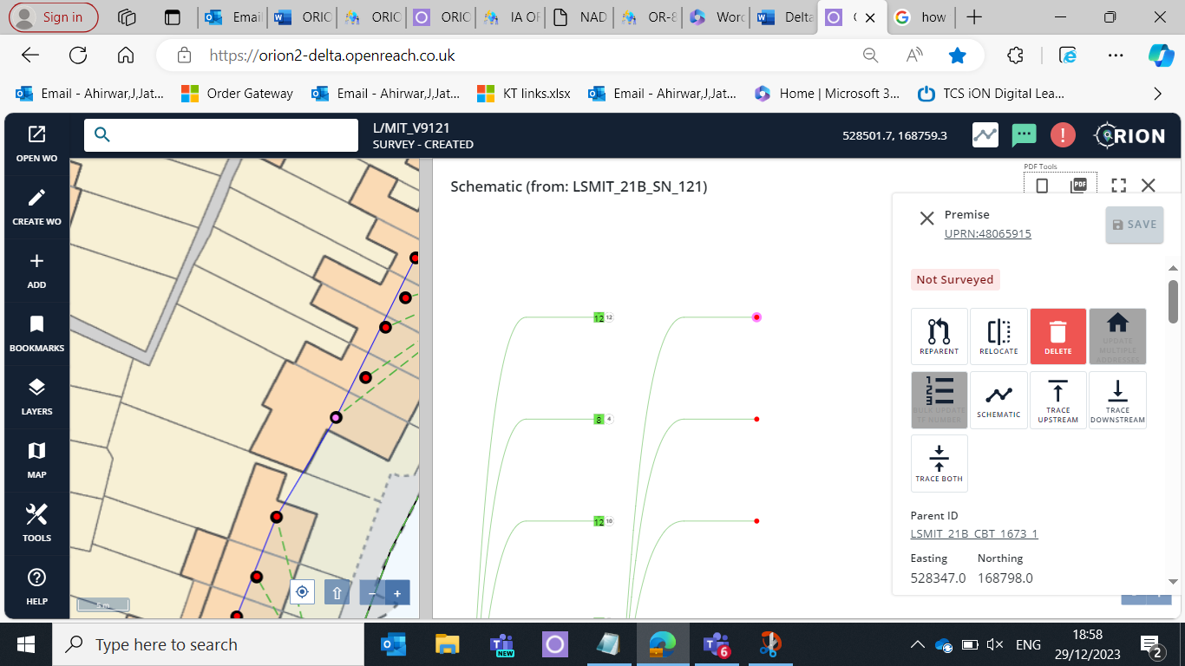

**UPRN:48065933**- ( I will tell address for the update address details from backed )

Update Address

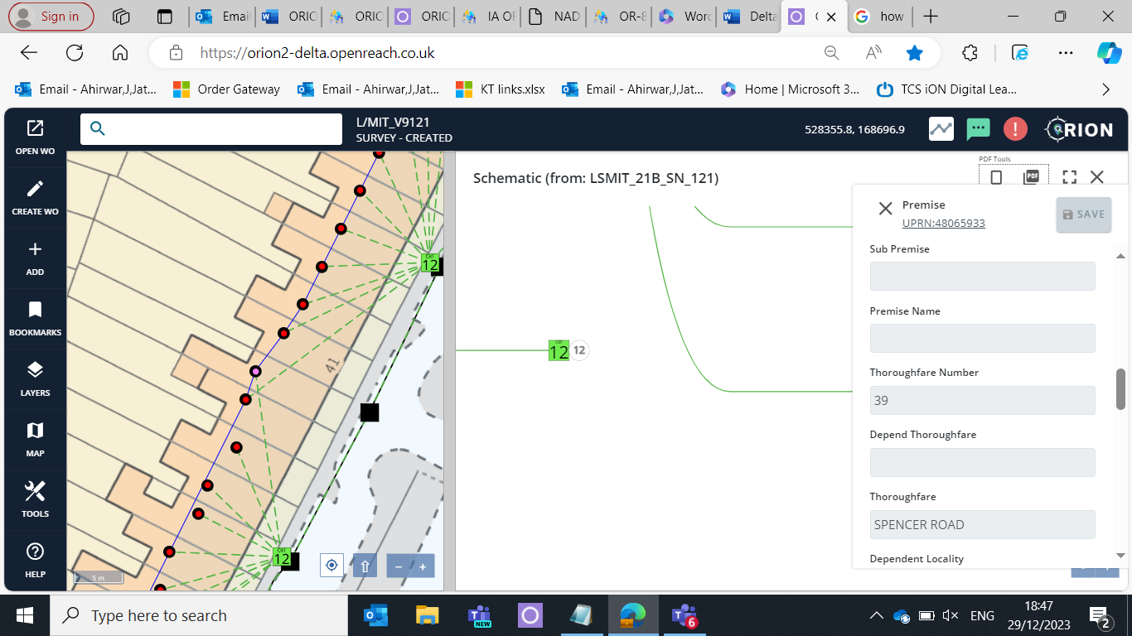

**Thoroughfare Number**

39-->50

**Thoroughfare**

SPENCER ROAD –> MAPPLE ROAD

**Post Town**

MITCHAM ---> SENTNER

**Postcode**

CR4 1SG ---> GB1 2TH

**UPRN:48008042**

Update the Address (She /they will update address from their end)

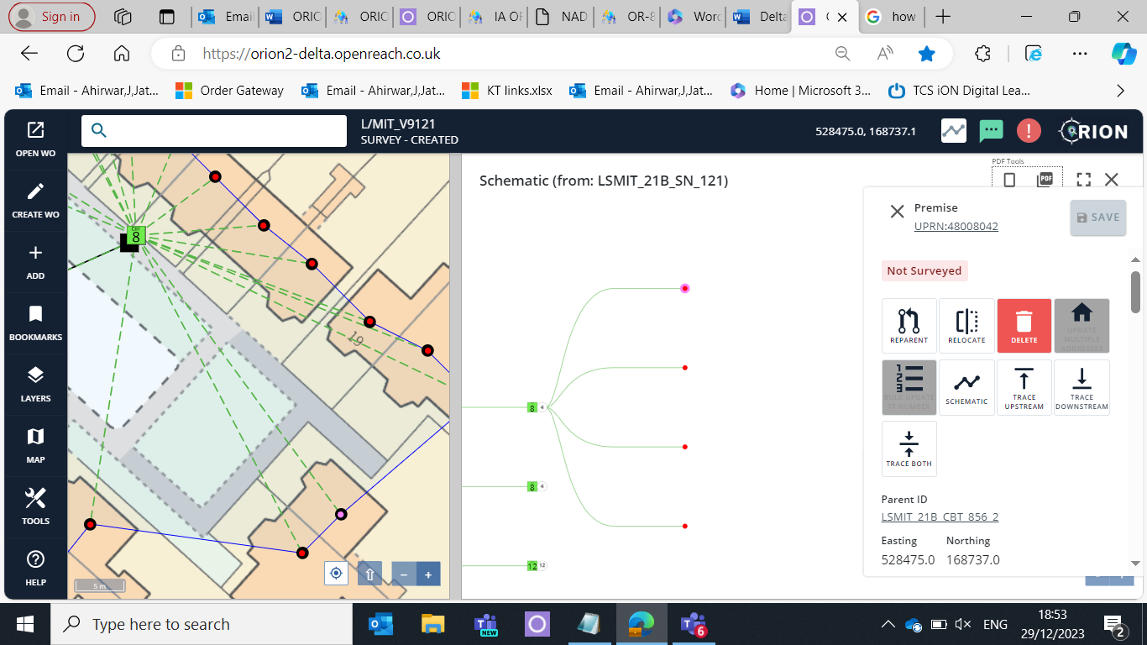

**UPRN:48107707** – Add CPE here

In this surface I need to add CPE

528501.7, 168759.3

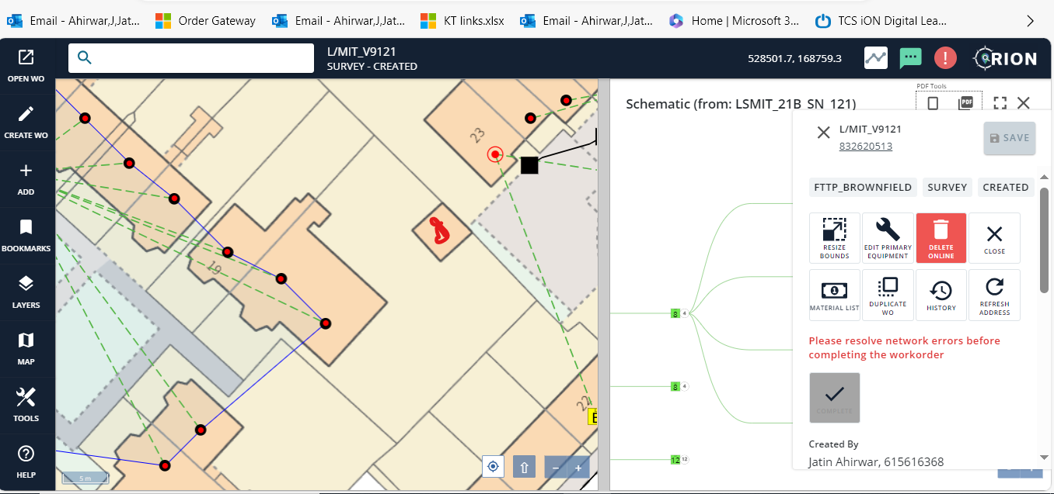

**UPRN:48065928**

Delete CPE from Scamatic---- 528395.7, 168804.0

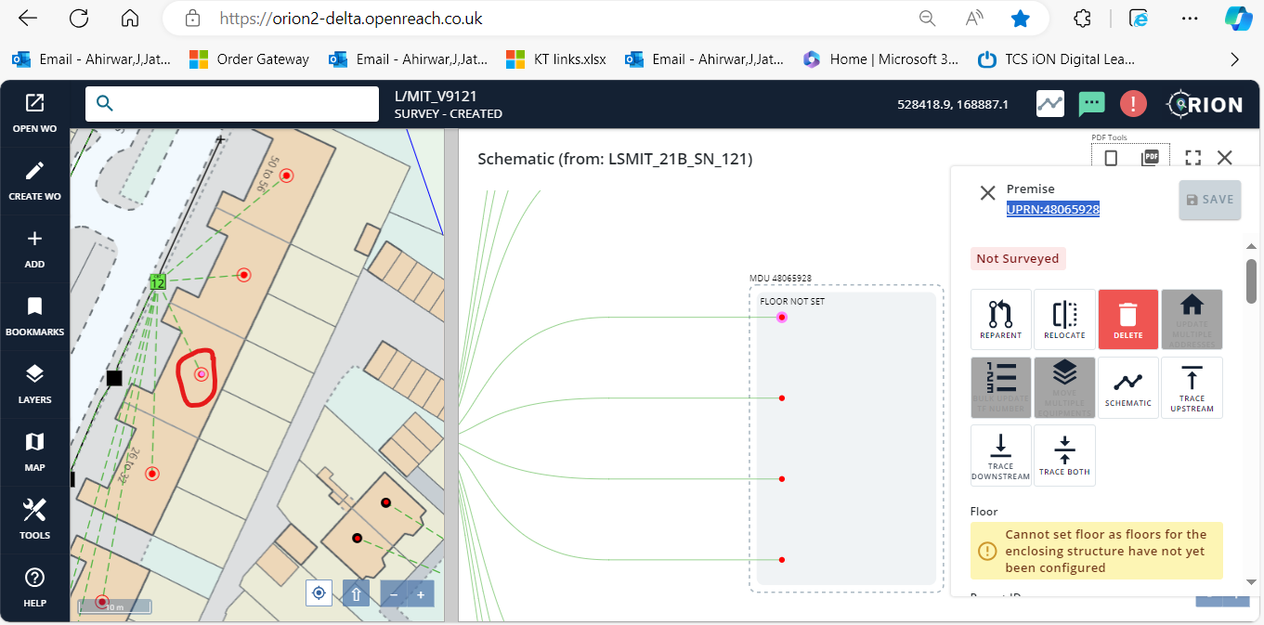

**UPRN:48008041**

Delete CPE from Scamatic and MaP

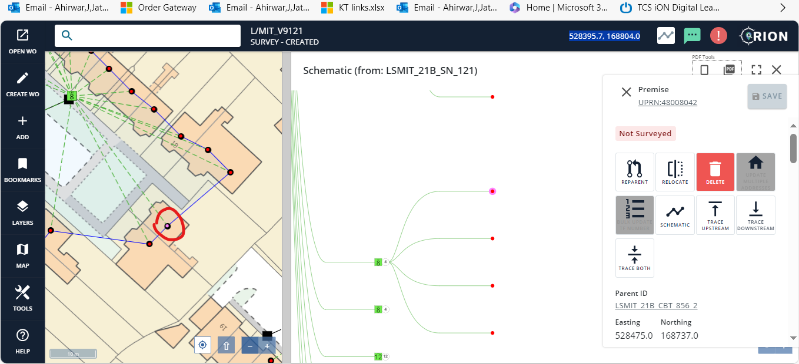

**UPRN:48065961 –** RPC Code --> 5

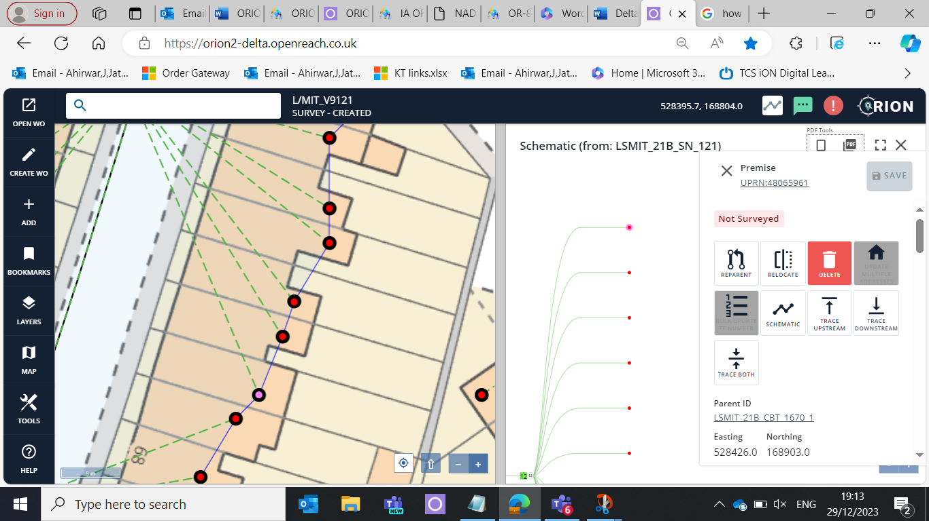

**UPRN:48065972**--- RPC Code --->7

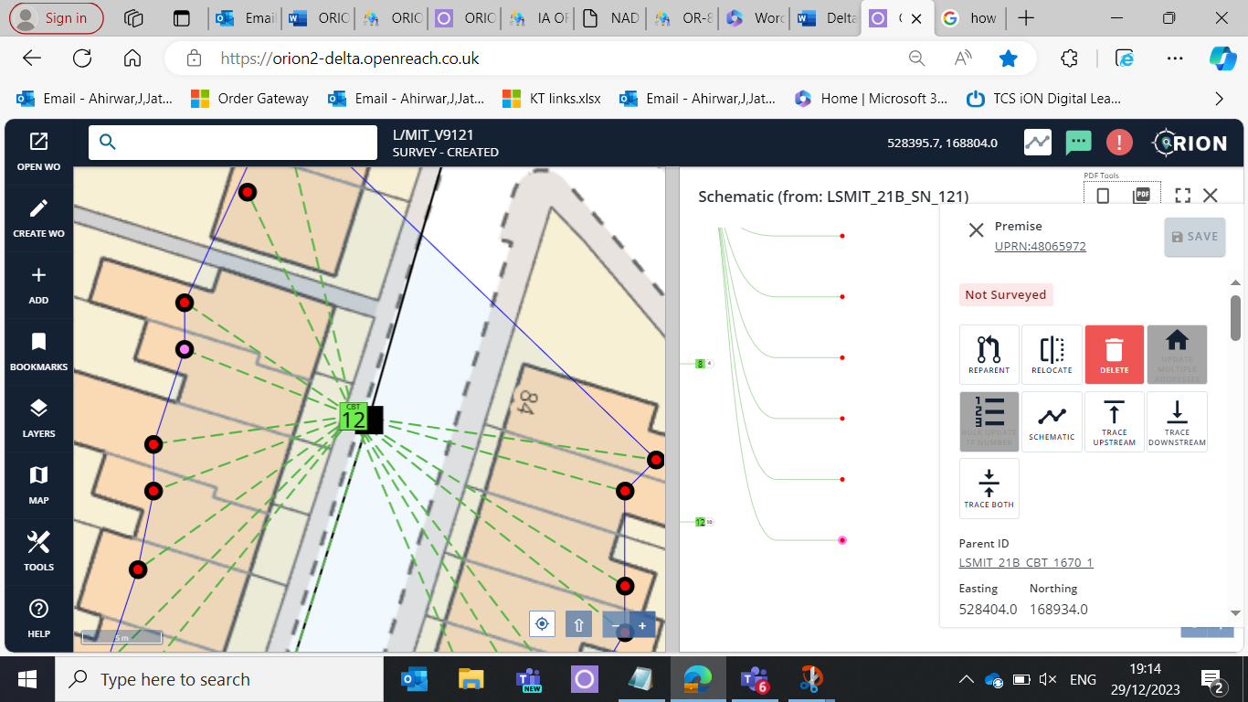

**UPRN:48065973**--- RPC Code ---> 3

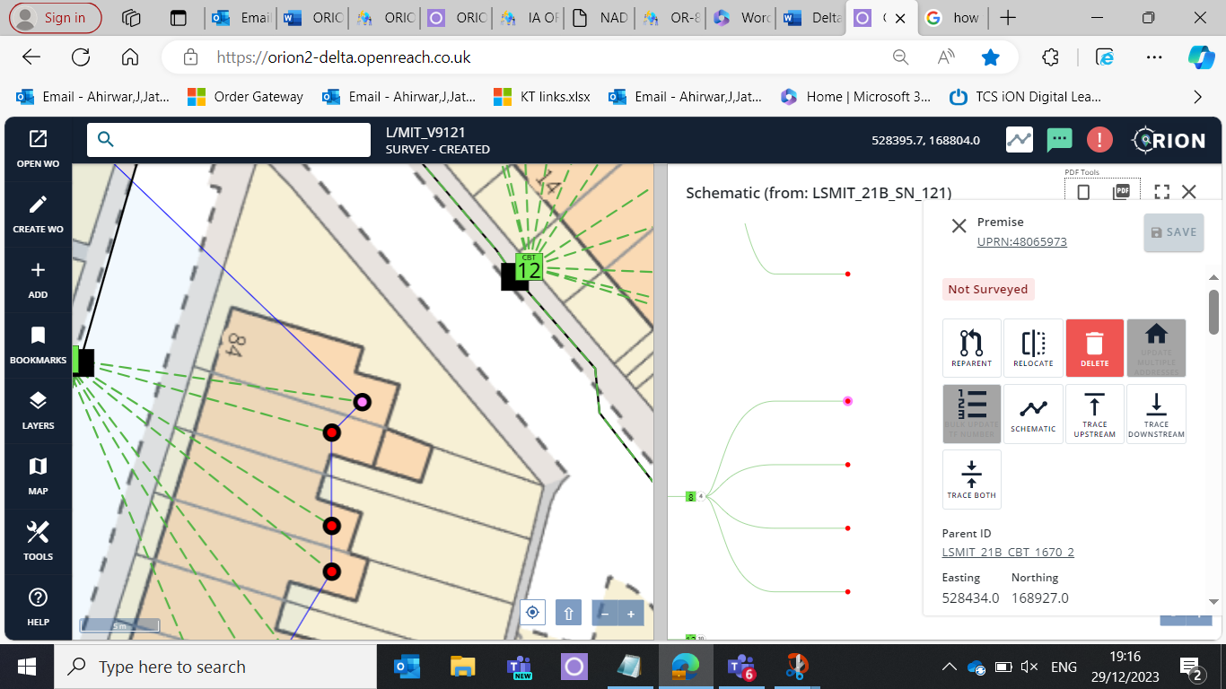

**UPRN:48065976**--- RPC Code --->1

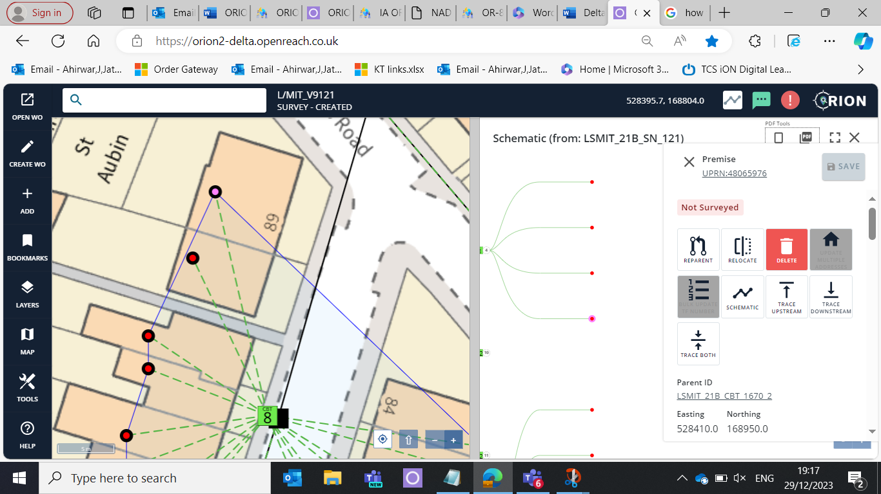

**UPRN:48065952**—RPC Code --- >2

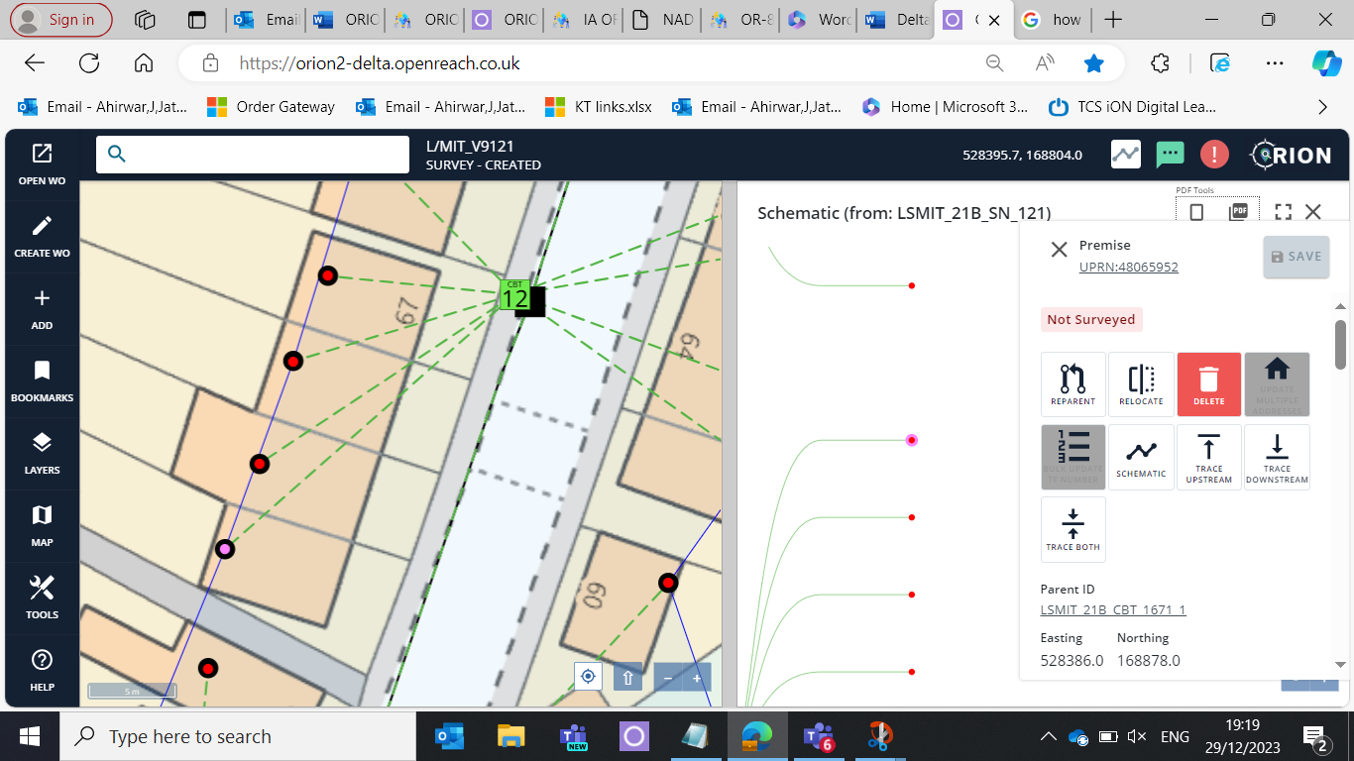

**UPRN:48065960** – RPC Code -->4

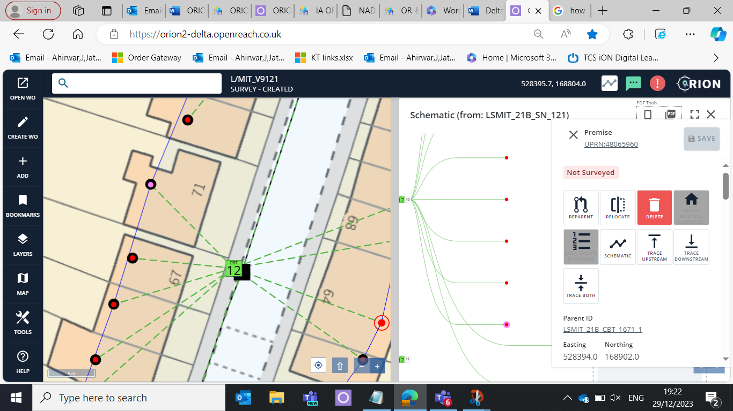

**UPRN:48008030**—RPC Code -->2

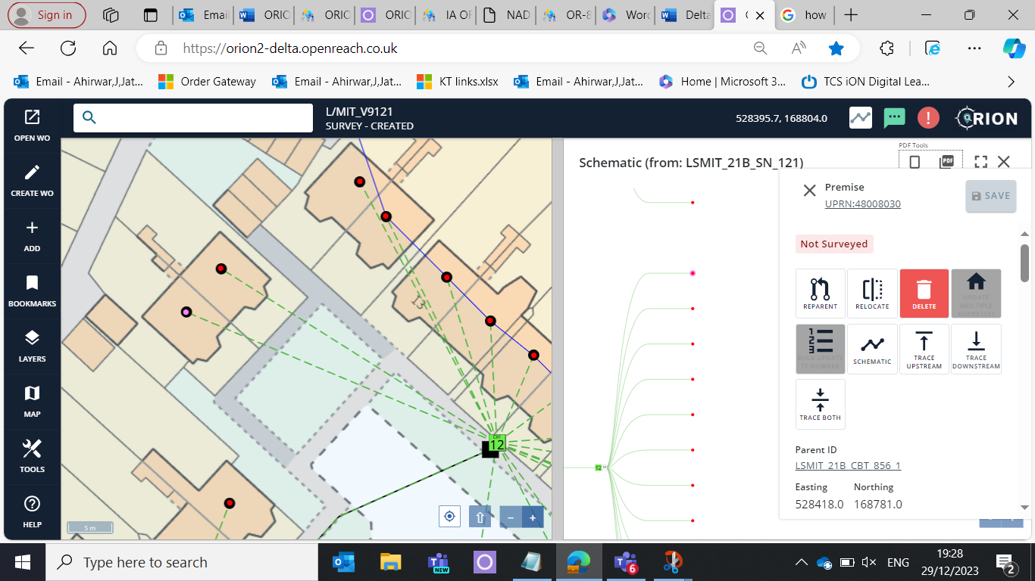

**UPRN:48065931** – RPC Code -->1

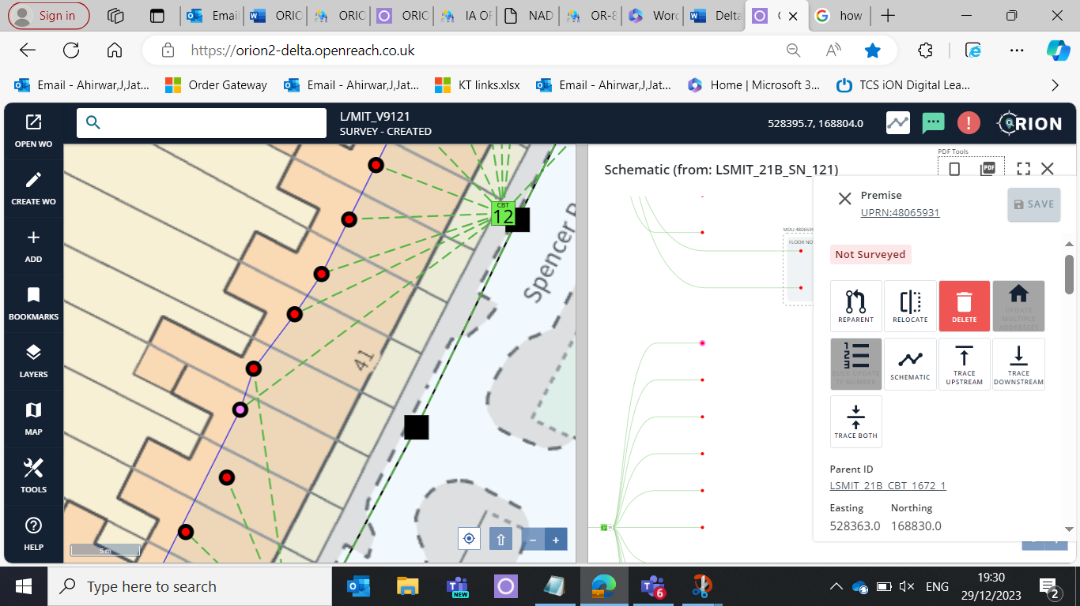

**UPRN:48085208**—RPC Code-->9

